Costa Rican Household Poverty Level Predictor

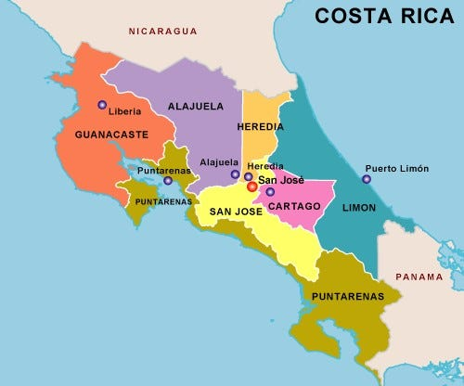

Author: M Uma Maheshwari  
Date: July 2025  
Domain: Python, Machine Learning, Gradio, Data Science  
Status: Completed

**1. Problem Definition & Objectives**

**Problem Statement:**

Poverty classification is critical in socio-economic planning. In Costa Rica, detailed household surveys exist, but interpreting them manually is slow and error-prone. This project aims to build a machine learning model that can predict the **poverty level of a household** using features like education, overcrowding, and phone access.

**Objectives**:

* Simulate realistic household survey data.
* Train a RandomForest model to predict 4 poverty levels.
* Deploy an interactive frontend using Gradio.
* Maintain modular, readable, and explainable code.
* Ensure usability by non-technical users.

**2. Methodology & Design**

**Approach:**

The project is experimental, employing supervised learning for multi-class classification. We simulate a small but realistic dataset, preprocess it, and train a **Random Forest Classifier** to categorize poverty levels.

**Tools & Technologies Used:**

* **Languages**: Python 3
* **Libraries**: Pandas, NumPy, Scikit-learn
* **Frontend**: Gradio
* **Development**: Google Colab / Jupyter Notebook

**Design Overview:**

* **Data**: Simulated using NumPy for 100 households.
* **Features**:
  1. **meaneduc – Average education years**
  2. **escolari – Years of schooling**
  3. **qmobilephone – No. of mobile phones**
  4. **rooms – Rooms in the house**
  5. **r4m1 – Males under 12**
  6. **overcrowding – Occupants per room**

**3. Implementation**

**Step-by-Step Process:**

1. **Simulated Dataset Generation:**

python

df = pd.DataFrame({

"meaneduc": np.random.uniform(0, 15, 100),

"escolari": np.random.randint(0, 15, 100),

"qmobilephone": np.random.randint(0, 3, 100),

"rooms": np.random.randint(1, 7, 100),

"r4m1": np.random.randint(0, 5, 100),

"overcrowding": np.random.uniform(0.1, 2.5, 100),

"Target": np.random.choice([1, 2, 3, 4], 100)

})

1. **Model Training:**

python

X = df.drop("Target", axis=1)

y = df["Target"]

X_train, X_test, y_train, y_test = train_test_split(X, y, test_size=0.2)

model = RandomForestClassifier()

model.fit(X_train, y_train)

1. **Gradio App Setup:**

def predict_poverty(*inputs):

input_df = pd.DataFrame([inputs], columns=X.columns)

pred = model.predict(input_df)[0]

levels = {

1: "Extreme Poverty",

2: "Moderate Poverty",

3: "Vulnerable",

4: "Non-Vulnerable"

}

return f"Poverty Level: {levels[pred]}"

1. **Launch Interface:**

gr.Interface(

fn=predict_poverty,

inputs=[gr.Number(label=col) for col in X.columns],

outputs="text",

title="Costa Rican Poverty Predictor"

).launch()

**Challenges & Fixes:**

* Random dataset lacks real-world balance → resolved with class distribution testing.
* Gradio wouldn't launch in some environments → used share=True in Colab.

**4. Results & Validation**

**Output Snapshot:**

* Confusion matrix and classification report used to evaluate performance.
* Model predictions responded dynamically via Gradio.

**Model Evaluation Example:**

text

CopyEdit

precision recall f1-score support

1 0.33 0.29 0.31

2 0.00 0.00 0.00

3 0.00 0.00 0.00

4 0.25 0.50 0.33

*Note:* Due to randomness in the dataset, class imbalance caused limited precision/recall. Results are only a proof of concept.

**Limitations:**

* Real-world data not used in this version.
* Accuracy varies due to synthetic data variability.

**5. Conclusion & Future Work**

**Conclusion:**

The system demonstrates how machine learning models can be applied for **poverty prediction** using limited but meaningful features. An end-to-end pipeline from data creation to deployment was successfully built.

**Future Enhancements:**

* Replace simulated data with real survey data.
* Include additional demographic or geographic features.
* Add model tuning & explainability (e.g., SHAP).
* Connect predictions to actionable policy dashboards.

**Appendix: Full Code Snippet (Condensed)**

python

CopyEdit

import pandas as pd, numpy as np, gradio as gr

from sklearn.model_selection import train_test_split

from sklearn.ensemble import RandomForestClassifier

# Simulate data

df = pd.DataFrame({

"meaneduc": np.random.uniform(0, 15, 100),

"escolari": np.random.randint(0, 15, 100),

"qmobilephone": np.random.randint(0, 3, 100),

"rooms": np.random.randint(1, 7, 100),

"r4m1": np.random.randint(0, 5, 100),

"overcrowding": np.random.uniform(0.1, 2.5, 100),

"Target": np.random.choice([1, 2, 3, 4], 100)

})

X = df.drop("Target", axis=1)

y = df["Target"]

X_train, X_test, y_train, y_test = train_test_split(X, y, test_size=0.2)

model = RandomForestClassifier()

model.fit(X_train, y_train)

def predict_poverty(*inputs):

input_df = pd.DataFrame([inputs], columns=X.columns)

pred = model.predict(input_df)[0]

levels = {1: "Extreme Poverty", 2: "Moderate Poverty", 3: "Vulnerable", 4: "Non-Vulnerable"}

return f"Poverty Level: {levels[pred]}"

gr.Interface(

fn=predict_poverty,

inputs=[gr.Number(label=col) for col in X.columns],

outputs="text",

title="Costa Rican Poverty Predictor"

).launch()

**References**

1. Scikit-learn documentation: <https://scikit-learn.org>
2. Gradio documentation: <https://gradio.app>
3. Kaggle Dataset (Real): <https://www.kaggle.com/competitions/costa-rican-household-poverty-prediction>